MFC Extensions
Chapter
9

mfcDocTemplateFinder

Requirements
Creates a user-interface for dealing with document templates similar to that found in Microsoft Word. Template files in Word are used as seed files when opening a new document. When a user selects File-New in Word, the following dialog box is opened: 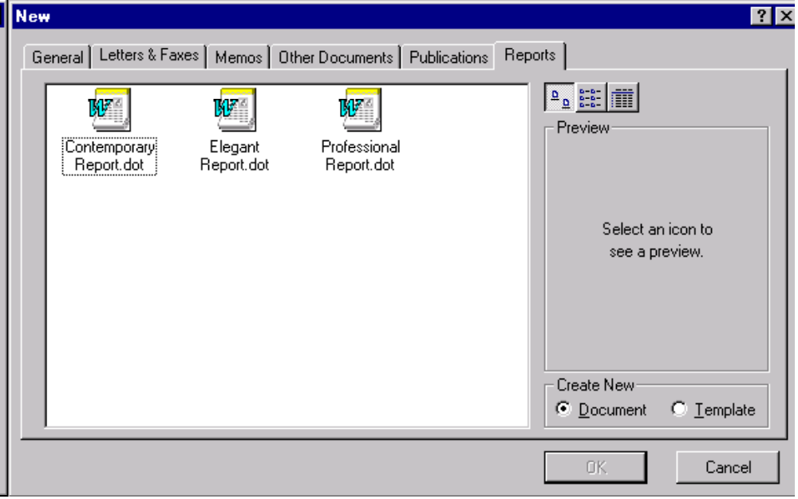The tabs on the dialog represent directories found by the “User Templates” and “Workgroup Templates” option settings in Word. Tabs in the dialog, other than “General”, correspond to the first-level subdirectories found underneath these directories. The files shown in the list control are the document template files found in those subdirectories. Files located directly in directories in the list will be put into the “General” tab.
The solution will be in the form of a control that must satisfy the following requirements:
- The calling application can set a vector of directory locations for the control to search for template files. The search will look in all subdirectories one level down from all directories in the list. Ordering in the list is important because this ordering will be used to resolve the elimination duplicate entries in subdirectories.
- The calling application can optionally set an icon to go along with the files to be selected. This icon will be displayed along with the names of the template files in the list control. The icon should support both 32x32 and 16x16 images. The class will support a default icon if none is explicitly set.
- The calling application will pass in the file name suffix of the template files to be searched for. Only one suffix is allowed.
- The user may only select one template file. When the user selects a file, the control will pass back a string which represents the full path to the template file. If no file is selected, the NULL string is passed back. This indirectly passes back the state of the result of the selection. Two results are possible: 1) the user canceled and, 2) the user selected a file and wants to open the template as a new document. This differs from Word which, in addition, allows you to open a new template file based on an existing template. this additional feature is unnecessary and confusing since any input file can be later saved as a template file.
- The list view will support the three standard modes of display: Large Icons, Small Icons, and List.
- The template selection dialog will not support the Preview feature seen in the Word dialog.

Since the directories names for the search paths passed into the control are likely to be typed in by users at some point, we can expect that there will be potential problems finding template files and resolving conflicts between them. Here is a listing of possible problems and resolutions for them.
Problem | Resolution
The same directory was passed into the list twice. | Ignore duplicate directories. Must figure out how to check this since the same directory can be specified many different ways.
Two directories in the list have subdirectories with the exact same name. | Create a tab with the name of the subdirectories and put all files from both into the list box. If files with identical names exist in the subdirectories, only list the file from the first directory in the list.
A subdirectory exists but has no template files in it. | Ignore it.
A subdirectory called “General” exists in one of the directories in the list | Add files into the General tab
A directory in the list does not exist | Ignore it.
Directory names only differ by case | Ignore case when comparing directory names. Display names in first letter uppercase format.
Directory names differ only by leading or trailing white space | Ignore leading and trailing white space.

Logical Design

Static Models
From the outside, the interface is very simple and can be represented by a single class, the mfcDocTemplateFinder class. This class will be directly implemented by non-exported CDialog-based class, CDocTemplateDialog, which will implement the user interface while the mfcDocTemplateFinder class implements the file and directory name manipulation logic (separate the “rules” from the display).
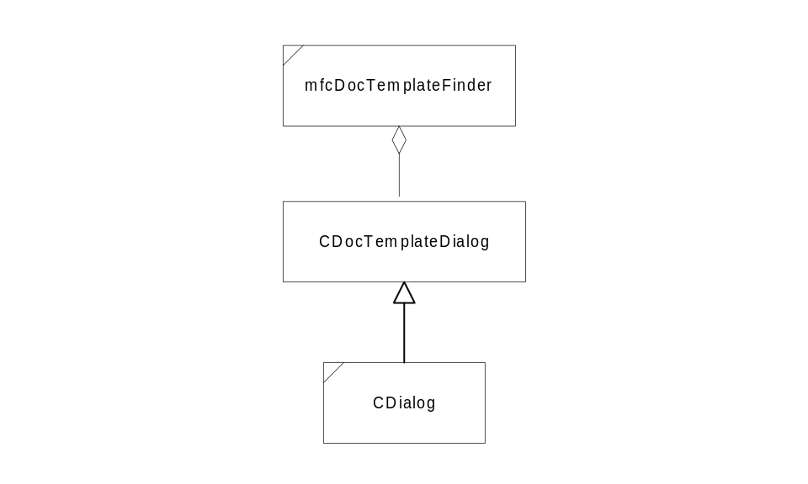

Physical Design

Specifications

mfcDocTemplateFinder

Public Interface - Member Functions
mfcDocTemplateFinder
mfcDocTemplateFinder();
Default constructor.
mfcDocTemplateFinder
mfcDocTemplateFinder(const std::vector<std::string>& directoryList, const std::string& suffix, ListMode mode=SmallIconMode);
Construct with a directory list, suffix and display mode.
SetDirectoryList
void SetDirectoryList(const std::vector<std::string>& directoryList);
Set up the list of directories that will be searched for template files. Each directory and all of its first-level subdirectories will be searched.
GetDirectoryList
void GetDirectoryList(std::vector<std::string>* directoryList) const;
Get the list of directories that will be searched for template files. Each directory and all of its first-level subdirectories will be searched.
SetFileSuffix
void SetFileSuffix(const std::string& suffix);
Set the suffix for the template files. Although any suffix will do, it is standard to use a three letter suffix for files on Windows platforms. For example, if you want to use *.dot as your template file suffix, pass in “dot” as the suffix string. A blank suffix string will cause an assert.
GetFileSuffix
std::string GetFileSuffix();
Get the suffix for the template files. Although any suffix will do, it is standard to use a three letter suffix for files on Windows platforms. A blank suffix string will cause an assert.
SetListMode
void SetListMode(ListMode mode);
Set the icon type for the list view.
GetListMode
ListMode SetListMode() const;
Get the icon type for the list view.
SetIcon
void SetIcon(HICON hIcon);
Sets the document template icon
GetIcon
HICON GetIcon() const;
Gets the document template icon
GetTemplateFile
bool GetTemplateFile(std::string* pFileName);
Pop up the user interface (dialog) and ask user to select a template file. Returns false if the action was canceled by the user, or if directory list is empty, or suffix string is null. If true is returned, the string will contain the entire path to the template file. If false is returned, the contents of pFileName is undefined.

Public Interface - enums
ListMode
enum ListMode { SmallIconMode, LargeIconMode, ReportMode};
Enum defining the types of list mode that the control can go into. This control support three modes:
- SmallIconMode - View small icons
- LargeIconMode - View large icons
- ReportMode - View in report mode.

